Gunnar Allison’s Portfolio



My name is Gunnar Allison, and I am currently a junior at Harvard studying mechanical engineering. This portfolio serves as a way of describing me, my projects, and my work experience. The table of contents below links to areas in the document that provide more information. Enjoy!

Contents

Contact Information: 2

My Courses: 2

Junior Spring (Current Courses): 2

Junior Fall: 2

Sophomore Spring: 2

Sophomore Fall: 2

Freshman Spring: 3

Freshman Fall: 3

Projects: 3

Human Powered Vehicle Challenge (HPVC) 3

Turf Wars Competition 4

ZCar Depot Engineering Intern 5

Electronic Guitar Tuner 7

Extracurriculars: 9

Varsity Track and Field 9

# Contact Information:

Cell phone number: +(1)-417-343-2791

College E-mail: [gunnar_allison@college.harvard.edu](mailto:gunnar_allison@college.harvard.edu)

Person E-mail: [gunnarlake@yahoo.com](mailto:gunnarlake@yahoo.com)

School Address: 64 Linnaean St. #208, Cambridge, MA 02138

Permanent Address: 9258 E State Hwy D, Rogersville, MO 65742

# My Courses:

## Junior Spring (Current Courses):

ENG-SCI 151: Applied Electromagnetism

ENG-SCI 96: Engineering Problem Solving and Design Project

ENG-SCI 183: Heat Transfer

ENG-SCI 123: Fluid Mechanics/Transport Processes

## Junior Fall:

ENG-SCI 181: Engineering Thermodynamics

ENG-SCI 125: Mechanical Systems

LPS A: Foundational Chemistry and Biology

CULTBLF22: The Ancient Greek Hero

## Sophomore Spring:

ENG-SCI 120: Mechanics of Solids

MATH 21B: Linear Algebra and Differential Equations

SPANISH 30: Upper Level Spanish

US-WORLD 34: United States Civil War: Nat Turner to Birth of a Nation

## Sophomore Fall:

COMPSCI 50: Introduction to Computer Science

MATH 21A: Multivariable Calculus

PHYSICS 12B: Electromagnetism and Statistical Physics from an Analytic, Numerical and Experimental Perspective

SPANISH 20: Intermediate Spanish

## Freshman Spring:

PHYSCI 12A: Mechanics from an Analytic, Numerical and Experimental Perspective

ENG-SCI 52: The Joy of Electronics – Part I

MATH 1B: Calculus, Series, and Differential Equations

SOCWORLD 54: Islam and Politics in the Modern Middle East

## Freshman Fall:

ENG-SCI 51: Computer-Aided Machine Design

MATH 1A: Introduction to Calculus

FRSEMR 42H: The U.S. Energy Revolution and its Implications

EXPOS 20: Expository Writing

# Projects:

## Human Powered Vehicle Challenge (HPVC)

Dates: August 2017-Present

Role: President

In the fall of my sophomore year, a few students and I founded the first human powered vehicle club at Harvard. With plans to compete at the 2018 ASME HPVC competition, we performed a multitude of research and testing on what it would take to make an ideal human-powered street vehicle. With sustainability as our primary goal in mind, we want to create a vehicle that convinces commuters to leave the car at the lot and opt for a vehicle that leaves no carbon footprint. In addition to sustainability, we asked what else we could do set our design apart from the bikes riding roads on a daily basis. To answer this question, we opted for a tadpole-style trike design for added stability, and we equipped it with a rollover bar protection system and extra cargo space between the rider and the back wheel.

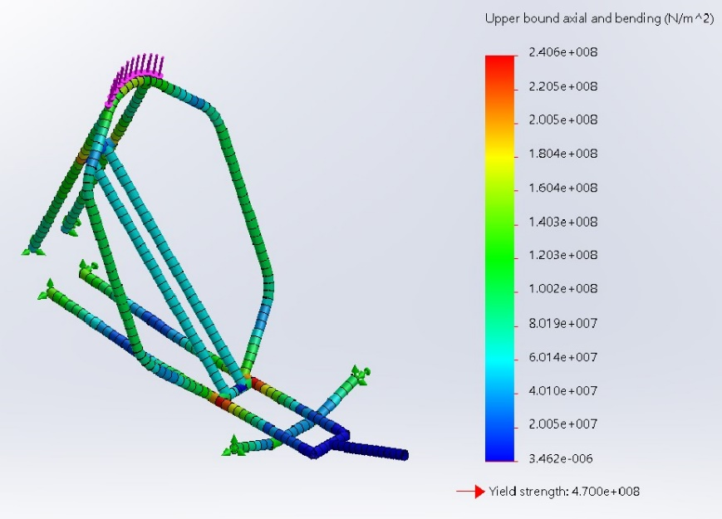 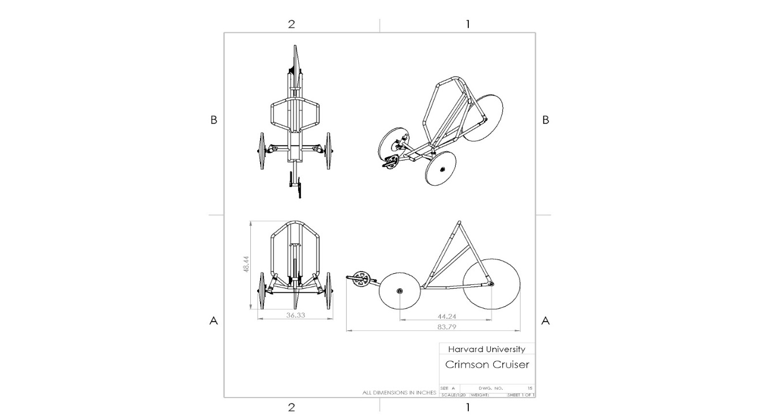

*Images: Frame loading simulation with 13.3 kN force (left) and four-view vehicle drawing (right).*

Our small team worked long hours to develop full CAD models of our intended product, but short staff for welding the vehicle together prevented us from finishing it in time for the competition. Even though the vehicle was not completed until the week after the competition, our design report and documentation *alone* were able to earn us a 39th place finish which beat out nine other teams. Wholly unsatisfied by this result, we resolved to regroup for the 2019 competition and attack the design process like never before. This year, our design switched to a two-wheel style to improve maneuverability and cut excess weight. Throughout both design process phases I became highly proficient at designing individual parts and assemblies in SolidWorks as well as conducting computerized finite element analyses on those components in SolidWorks. Engineering courses at Harvard teach so much about the theory behind several topics, but very few can put students into the real work facing difficult design decisions like extracurricular projects can. The human powered vehicle club has taught me so much about the journey of bringing an idea from pen and paper to the real-world, and I look forward to what the future holds for this club.

## Turf Wars Competition

Date: Fall 2016

Role: Team Member/Designer/Builder

In my first year as a student at Harvard, two students and I were challenged to build a one cubic-foot-sized robot that could navigate an obstacle course, grasp tennis balls and lift them 18 inches high to a Velcro scoring wall. Our team created the highest-scoring and most maneuverable robot of them all, and in doing so we became excelled in SolidWorks rendering, report documentation, machining (3D printing, laser-cutting, CNC milling, lathe), and rapid prototyping. The drivetrain of the robot utilized repurposed DC motors while servo motors were used to control the claw and lifting system. The frame and wheels were composed of laser-cut acrylic, and the silicone tires were produced from a mold that was built by layering acrylic walls.

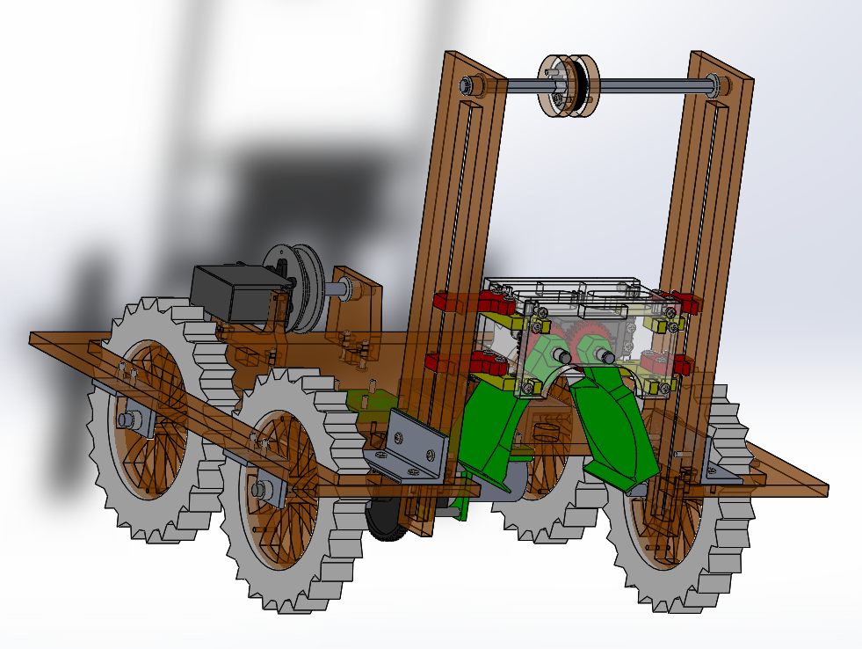

*Image: Final Robot Assembly (SolidWorks Rendering)*

## ZCar Depot Engineering Intern

Date: Summer 2018

Role: Engineering Design Intern

As an engineering intern for ZCar Depot, my task was to identify ways that 3D printing could maximize profit and product quality. Given product areas that fit that criteria, my role was to design custom and OEM car parts through CAD to be produced through 3D printing without support structures. In this experience, I garnered high proficiency in SolidWorks and Fusion 360, and in troubleshooting/installing/maintaining a line of 3D printers I became more acquainted with G-code in additive manufacturing slicer software. Over the last two summers, I designed and engineered over 150 Datsun car parts from grommets and dashboard buttons to mirror mounts and steering column shrouds.

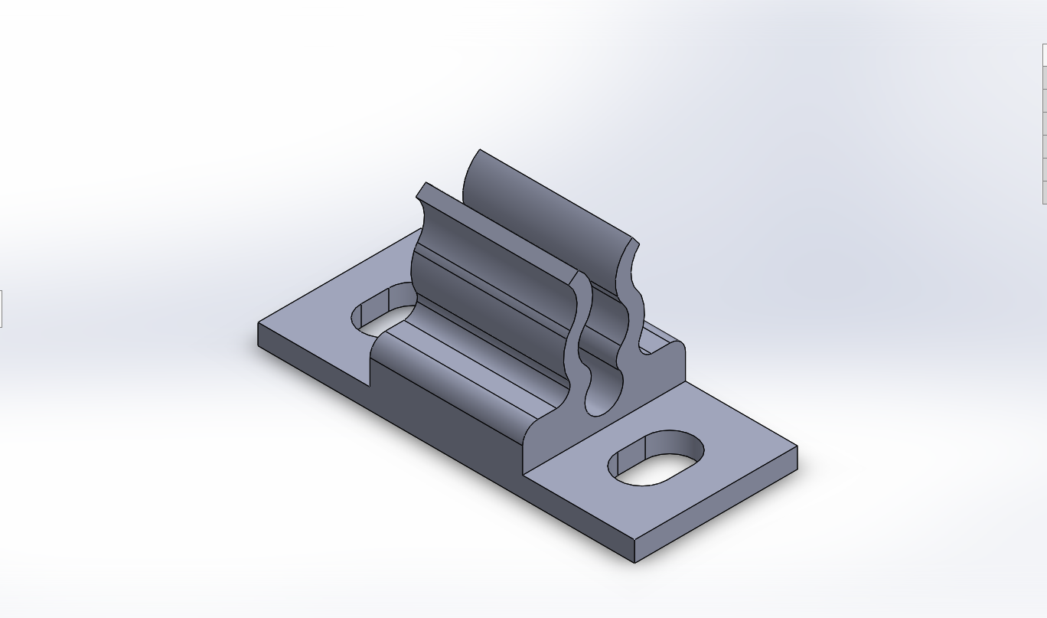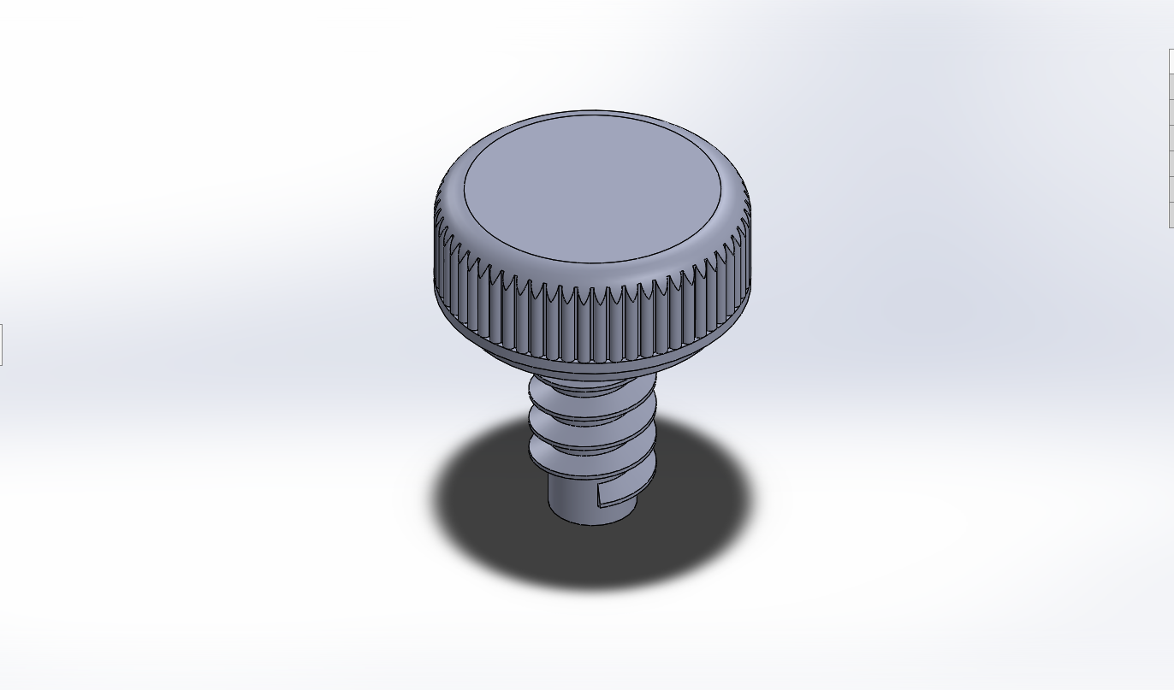

*Images: battery inspection plate clip (left) and dashboard thumb screw (right)*

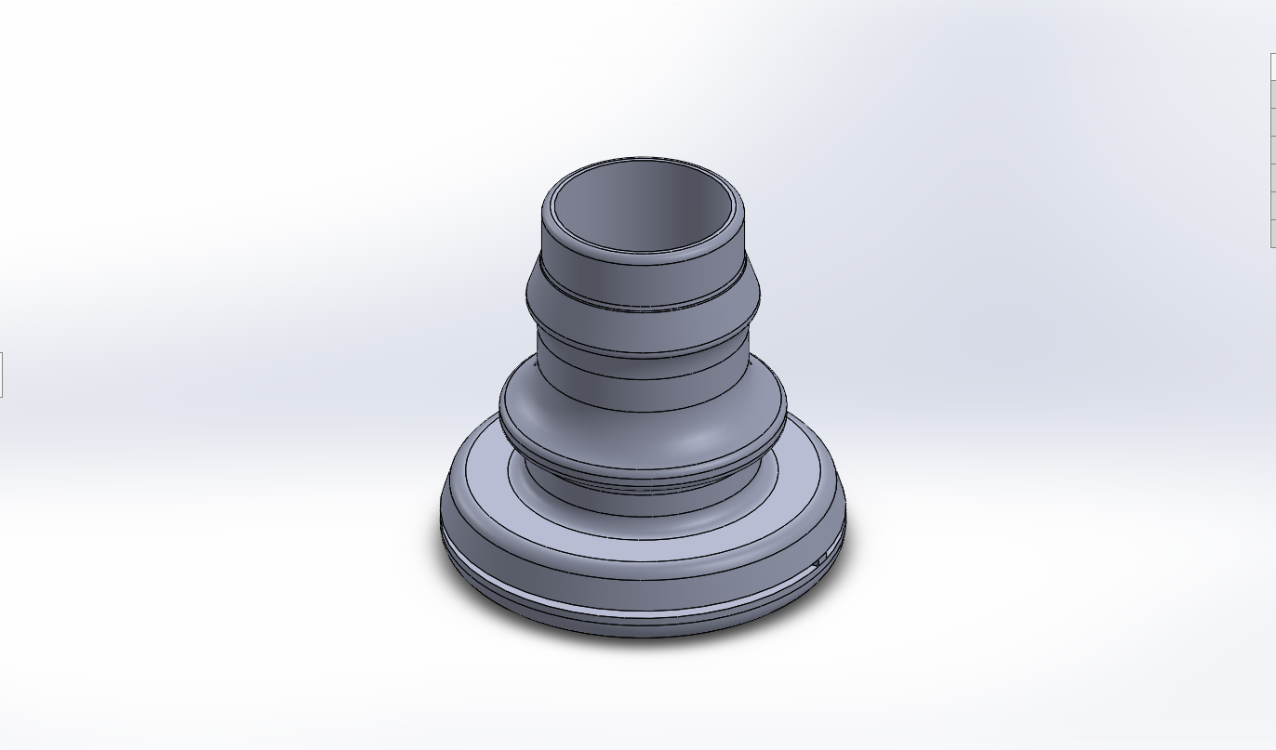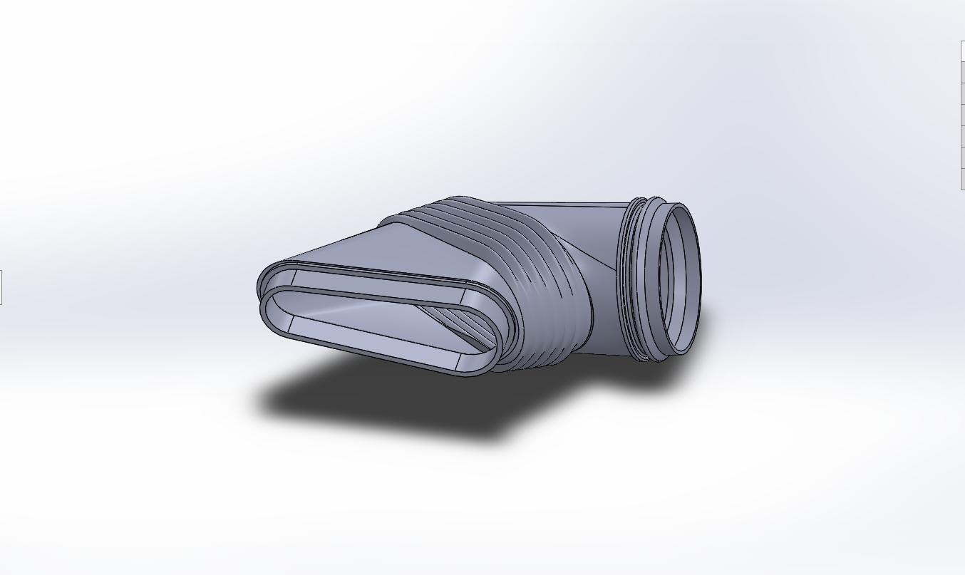

*Images: firewall wire grommet (left) and air intake induction duct (right)*

In my most recent summer with the company, I oversaw the design of a hybrid-drive system for a Datsun 280z. This powertrain utilized the existing Chevrolet LS1 driveline for the combustion component and added a NetGain Hyper9 AC electric motor for the electric power. The electric motor was mounted in a blower position running a pulley and belt off of its pinion directly to the crankshaft of the existing motor. The Hyper9 is the highest efficiency motor available on the market, and it is capable of outputting peak pulls at 100 kW. At or below 3500 RPM, the motor is characterized by the factory at delivering ~170 lbs.-ft of torque, which compensates for the combustion engine which does not reach its peak torque until beyond that range from 3500-4500 RPM. In order to run the motor near peak current, which is 750 amps, our team employed the use of Lonestar EV Performance’s high-current-drain lithium-ion cells arranged in a 3kWh battery pack. This battery pack is mounted in the rear of the vehicle along with the charger and battery management system, and the motor controller is mounted behind the motor. Aftermarket hybrid systems like this have been shown in the past to improve fuel efficiency, especially in larger vehicles. For this project, the goal was to unite combustion with electric in order to achieve speed.

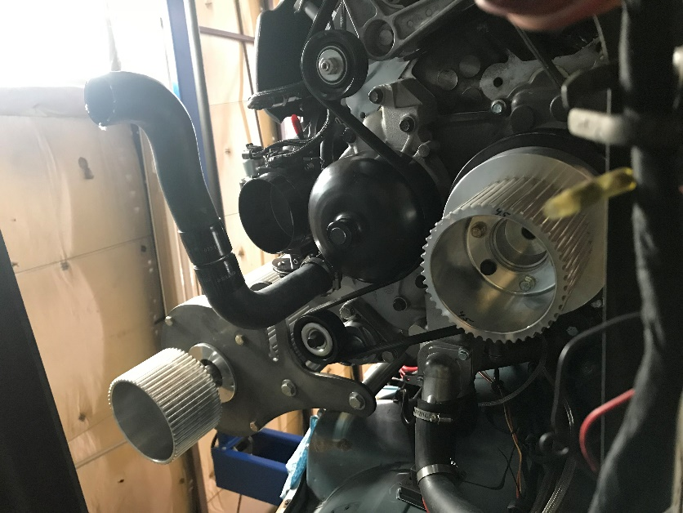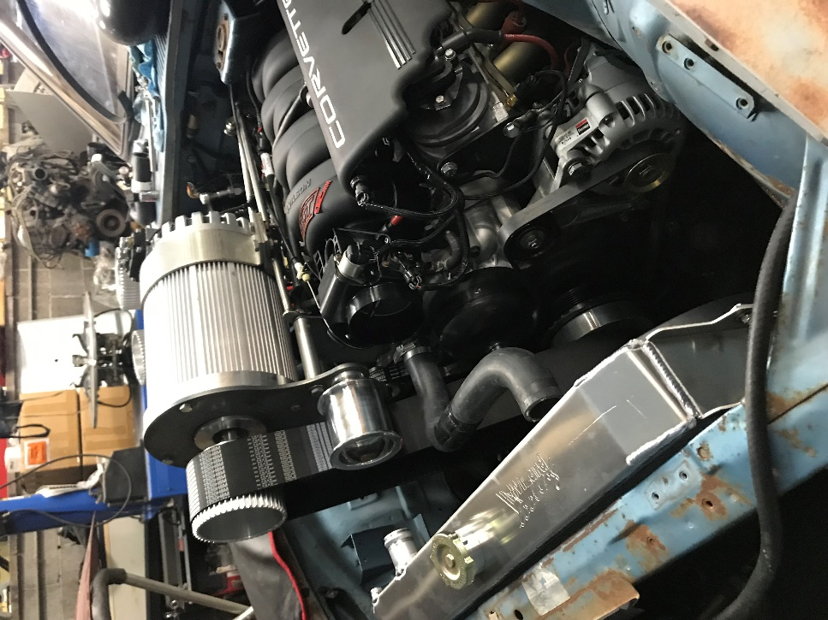

*Images: front view of engine bay (left) and top view from alternator side (right)*

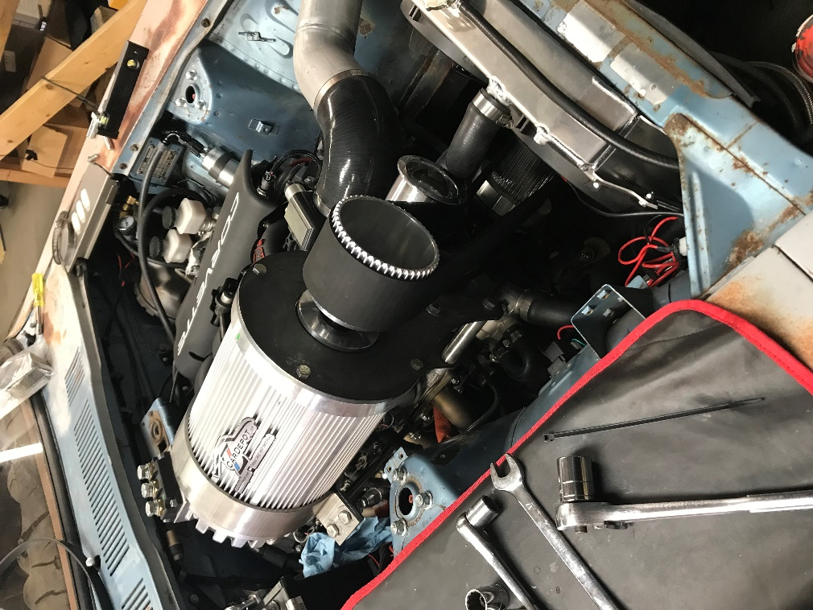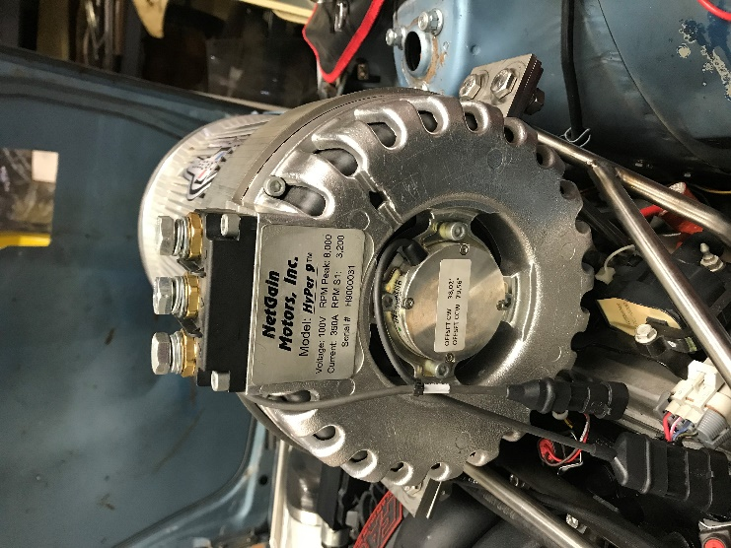

*Images: top view of engine bay from electric motor side (left) and rear of motor (right)*

*Company Link:* [*https://zcardepot.com/*](https://zcardepot.com/)

## Electronic Guitar Tuner

Date: Spring 2017

Role: Design Co-Lead

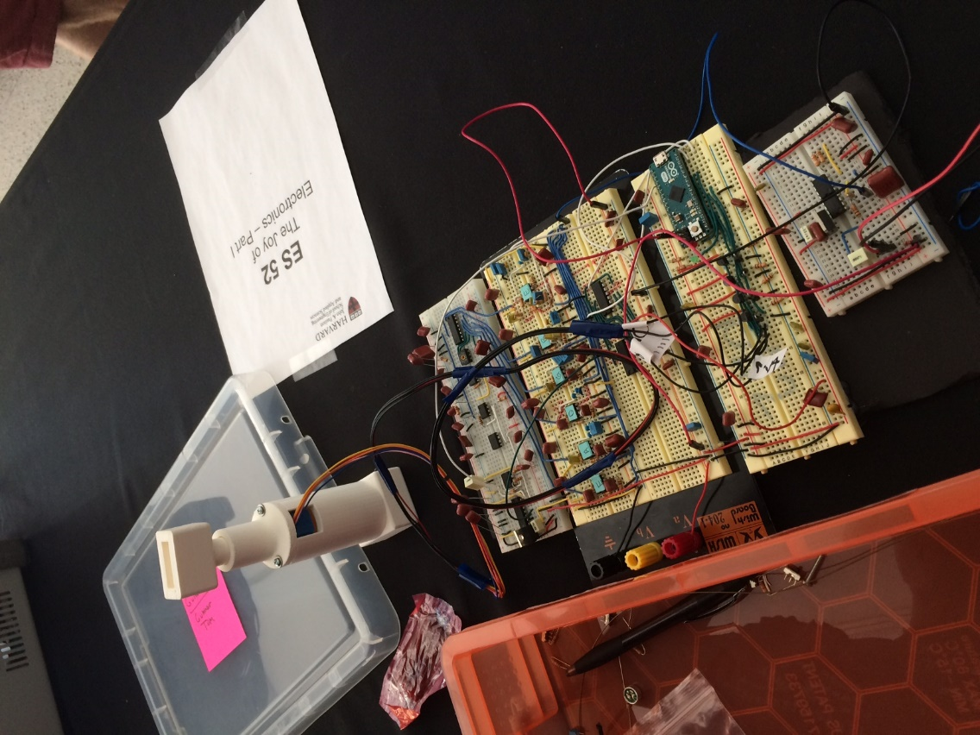

During my introductory electrical engineering course, my friend and I decided to build automatic guitar tuner for our final project. In designing this device, we wanted to create an instrument that expedited the process of tuning the guitar. Instead of providing user feedback so that the guitar player can keep plucking the guitar and tuning the string, we wanted to create a circuit with a feedback loop that automatically tightened or loosened the string to the right frequency. Naturally, a major component of this circuit that performed this process was frequency detection. Since a guitar string produces a rich sound with many harmonics, we needed higher order filters for each string in order to attenuate higher harmonics and concentrate on the fundamental of the string being tuned. The sound of the guitar would be picked up through a microphone, amplified, sent through the correct filter, and then turned into a square wave for frequency measurement. A comparator circuit was used to convert the audio signal to a 0-5V square wave, which would then be AND gated with a 2 Hertz 555 timer to create a 250 millisecond sampling period. This period of “clocking” AND outputs would be sent to 12 stage ripple counter which would then shift its binary outputs into a shift register at the end of the sampling period. This 8-bit binary reference would shift serially into the Arduino, at which point the 8-bit value would be read as decimal and compared with the desired frequency of the guitar. Depending on whether the string was sharp or flat, the Arduino would program a stepper motor driven by mosfet transistors to turn the tuning peg on the guitar clockwise or counterclockwise. The motor would was handheld in a 3D printed ergonomic case, and the user simply had to pluck the string and hold the motor on the correct string’s tuning peg in order to tune the string.

The following images are the hand-drawn final schematics of the circuit:

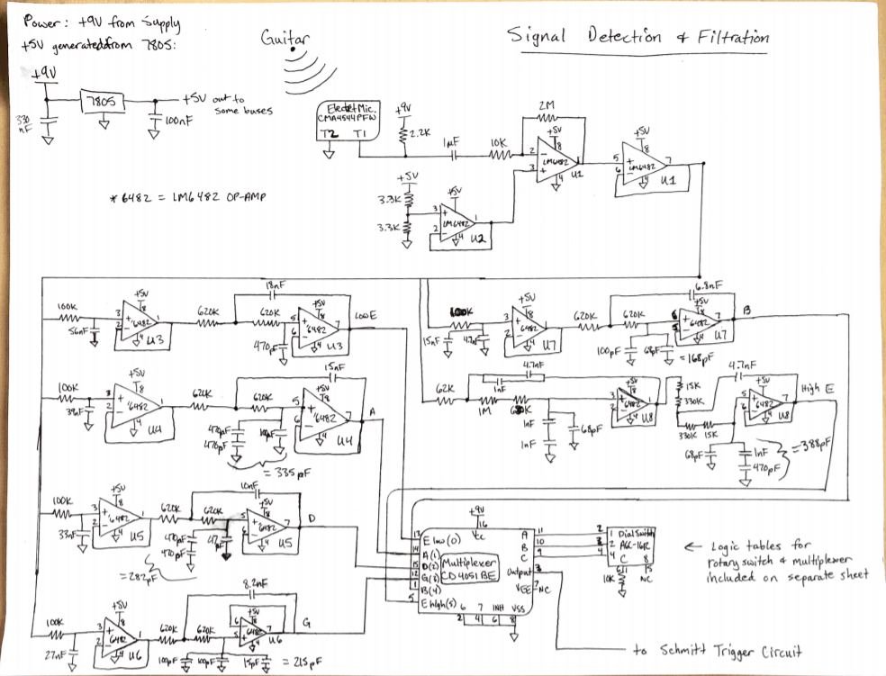

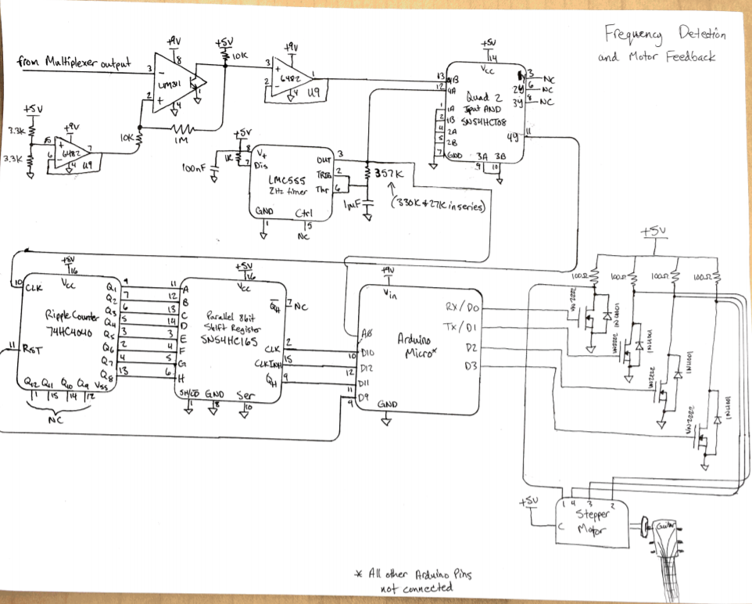

# Extracurriculars:

## Varsity Track and Field

Date: Fall 2016 – Present

Role: Thrower (Hammer, Discus, Shot Put, Weight)

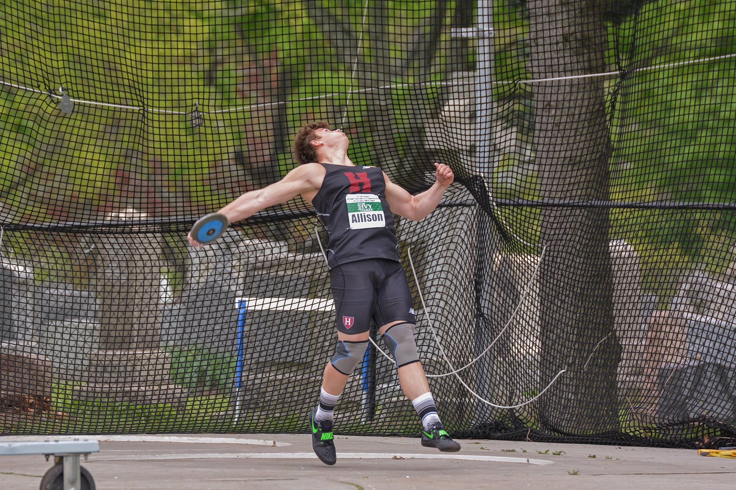 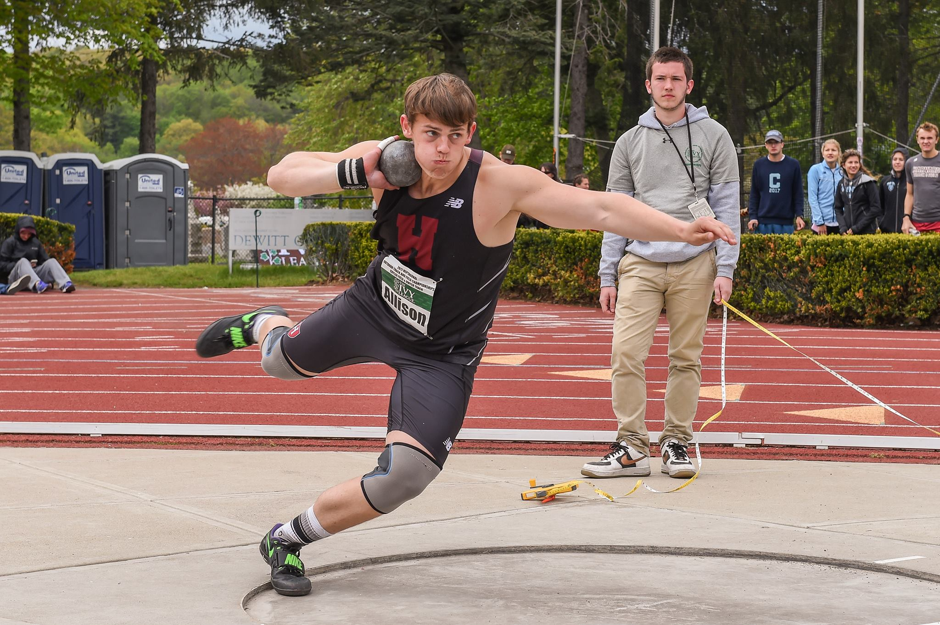

*Images: Discus throw (left) and shot put (right) @ 2017 Ivy League Outdoor HEPS Championship*

Since I picked up the discus at age 10, I have thrown myself to state championships, Ivy League medals, and even an international victory. The sport of throwing is as ancient as sport itself, but every day at practice I find new ways that it can be exciting and challenging. When I started throwing for the Crimson during my freshman year, rest and recovery would turn out to be a key ingredient for success while training 25 hours a week in a Division I sports program. Harvard engineering had other plans, however, but in spite of achieving very little sleep, I managed to play a big role in Harvard throws. In the middle of my freshman season, the Oxford and Cambridge teams travelled to our part of the world for the quadrennial Trans-Atlantic series competition, also known as the HYOC meet (where Harvard and Yale team up against Oxford and Cambridge). I was selected as a member of the throws squad and I ended up winning the discus event in a track competition with a history that pre-dates the modern Olympics. Later on that season, I outlasted a field of senior competitors to climb atop the conference championship podium and earn points for the men’s team. My sophomore season was not one to remember due to a month-long bout with Pneumonia, but my preparation since then has set me up for a fantastic junior campaign and I am excited to see what I can earn this outdoor season.